Assignment No. 2

Solution:
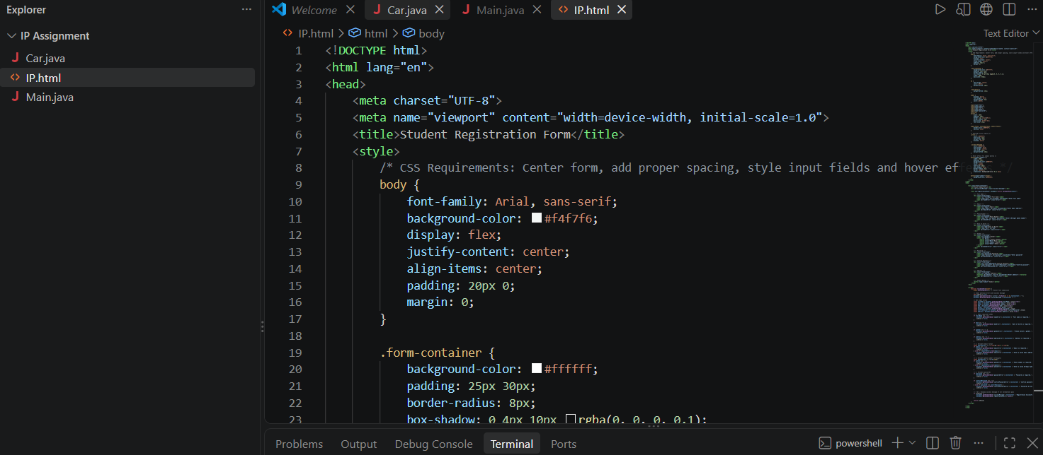

Code:
<!DOCTYPE html>
<html lang="en">
<head>
<meta charset="UTF-8">
<meta name="viewport" content="width=device-width, initial-scale=1.0">
<title>Student Registration Form</title>
<style>
/* CSS Requirements: Center form, add proper spacing, style input fields and hover effects */
body {
font-family: Arial, sans-serif;
background-color: #f4f7f6;
display: flex;
justify-content: center;
align-items: center;
padding: 20px 0;
margin: 0;
}

.form-container {
background-color: #ffffff
padding: 25px 30px;
border-radius: 8px;
box-shadow: 0 4px 10px rgba(0, 0, 0, 0.1);
width: 100%;
max-width: 450px;
}

h2 {
text-align: center;
color: #333;
margin-bottom: 20px;
}

.form-group {
margin-bottom: 15px;
}

label {
display: block;
font-weight: bold;
margin-bottom: 5px;
color: #555;
}

input[type="text"],
input[type="email"],
input[type="tel"],
input[type="date"],
input[type="password"],
textarea,
select {
width: 100%;
padding: 10px;
border: 1px solid #ccc;
border-radius: 4px;
box-sizing: border-box;
font-size: 14px;
}

input:focus, textarea:focus, select:focus {
border-color: #007bff;
outline: none;
}

/* Styling errors clearly */
.error {
color: #d9534f;
font-size: 12px;
margin-top: 4px;
display: block;
}

.success-message {
color: #28a745;
font-weight: bold;
text-align: center;
font-size: 16px;
margin-bottom: 15px;
}

/* Hover effect for submit button */
button[type="submit"] {
width: 100%;
padding: 12px;
background-color: #007bff;
border: none;
color: white;
font-size: 16px;
font-weight: bold;
border-radius: 4px;
cursor: pointer;
transition: background-color 0.3s ease;
}

button[type="submit"]:hover {
background-color: #0056b3;
}
</style>
</head>
<body>

<div class="form-container">
<h2>Student Registration</h2>
<div id="successMessage" class="success-message"></div>

<form id="registrationForm" onsubmit="return validateForm(event)">

<!-- Full Name -->
<div class="form-group">
<label for="fullName">Full Name</label>
<input type="text" id="fullName" placeholder="Enter full name">
<span id="nameError" class="error"></span>
</div>

<!-- Email -->
<div class="form-group">
<label for="email">Email</label>
<input type="email" id="email" placeholder="Enter email address">
<span id="emailError" class="error"></span>
</div>

<!-- Phone Number -->
<div class="form-group">
<label for="phone">Phone Number</label>
<input type="tel" id="phone" placeholder="Enter 10-digit phone number">
<span id="phoneError" class="error"></span>
</div>

<!-- Date of Birth -->
<div class="form-group">
<label for="dob">Date of Birth</label>
<input type="date" id="dob">
<span id="dobError" class="error"></span>
</div>

<!-- Gender -->
<div class="form-group">
<label for="gender">Gender</label>
<select id="gender">
<option value="">Select Gender</option>
<option value="Male">Male</option>
<option value="Female">Female</option>
<option value="Other">Other</option>
</select>
<span id="genderError" class="error"></span>
</div>

<!-- Password -->
<div class="form-group">
<label for="password">Password</label>
<input type="password" id="password" placeholder="Enter password">
<span id="passwordError" class="error"></span>
</div>

<!-- Confirm Password -->
<div class="form-group">
<label for="confirmPassword">Confirm Password</label>
<input type="password" id="confirmPassword" placeholder="Confirm password">
<span id="confirmPasswordError" class="error"></span>
</div>

<!-- Address -->
<div class="form-group">
<label for="address">Address</label>
<textarea id="address" rows="3" placeholder="Enter address"></textarea>
<span id="addressError" class="error"></span>
</div>

<!-- Submit Button -->
<button type="submit">Submit</button>
</form>
</div>

<script>
function validateForm(event) {
event.preventDefault(); // Prevent form submission

// Clear previous errors and success message
let isValid = true;
document.querySelectorAll('.error').forEach(el => el.textContent = '');
document.getElementById('successMessage').textContent = '';

// Get input values
const fullName = document.getElementById('fullName').value.trim();
const email = document.getElementById('email').value.trim();
const phone = document.getElementById('phone').value.trim();
const dob = document.getElementById('dob').value.trim();
const gender = document.getElementById('gender').value;
const password = document.getElementById('password').value;
const confirmPassword = document.getElementById('confirmPassword').value;
const address = document.getElementById('address').value.trim();

// 1. Check required fields
if (fullName === '') {
document.getElementById('nameError').textContent = 'Full name is required.';
isValid = false;
}

if (dob === '') {
document.getElementById('dobError').textContent = 'Date of birth is required.';
isValid = false;
}

if (gender === '') {
document.getElementById('genderError').textContent = 'Please select a gender.';
isValid = false;
}

if (address === '') {
document.getElementById('addressError').textContent = 'Address is required.';
isValid = false;
}

// 2. Validate email format
const emailPattern = /^[^\s@]+@[^\s@]+\.[^\s@]+$/;
if (email === '') {
document.getElementById('emailError').textContent = 'Email is required.';
isValid = false;
} else if (!emailPattern.test(email)) {
document.getElementById('emailError').textContent = 'Enter a valid email address.';
isValid = false;
}

// 3. Validate phone number (10 digits)
const phonePattern = /^[0-9]{10}$/;
if (phone === '') {
document.getElementById('phoneError').textContent = 'Phone number is required.';
isValid = false;
} else if (!phonePattern.test(phone)) {
document.getElementById('phoneError').textContent = 'Enter a valid 10-digit phone number.';
isValid = false;
}

// 4. Validate passwords
if (password === '') {
document.getElementById('passwordError').textContent = 'Password is required.';
isValid = false;
}

if (confirmPassword === '') {
document.getElementById('confirmPasswordError').textContent = 'Confirm password is required.';
isValid = false;
} else if (password !== confirmPassword) {
document.getElementById('confirmPasswordError').textContent = 'Passwords do not match.';
isValid = false;
}

// 5 & 6. Display success message if all validations pass
if (isValid) {
document.getElementById('successMessage').textContent = 'Registration Successful!';
document.getElementById('registrationForm').reset();
}

return isValid;
}
</script>

</body>
</html>

Output:
